Topic Name:
CdTe Solar Cell

Requirements:
- Presentation Slides
- Concepts to Cover
- Device design:
i. Doping Concentrations
Ii. Optical Absorption
ii. Energy Band Diagram
iii. PN Junction Diagrams
iv. Generation & Recombination
vi. Efficiency
Vii. Material improvement

C.
- Computer Simulation - Matlab, Nanohub( layer), setfos, scaps 1
- Supporting Content

Setfos

Slides & Content Outline: https://docs.google.com/presentation/d/17njrhnuqbz2z6tMmvCwy3JT0laINQhbrv-__JvxB8XQ/edit?usp=sharing

- Introduction (Opening Slide)
- Working Principle of A Solar Cell
  - Block Diagram of Conversion & Concept ( Sunlight>Solar Cell> Current> Battery)
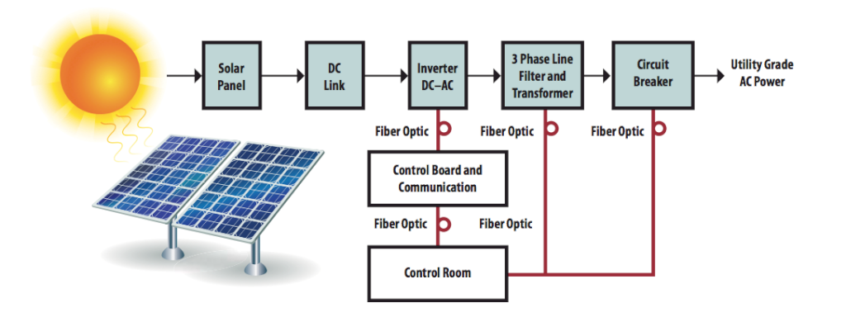

- Why CdTe solarcells are preferred over Si Solar Cells
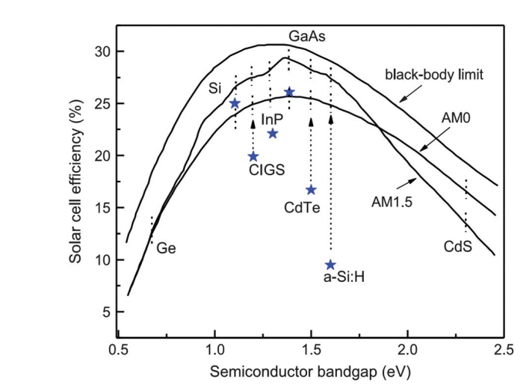
Bullet points in the same slide

- CdTe Solar Cell Structure
  - Diagram
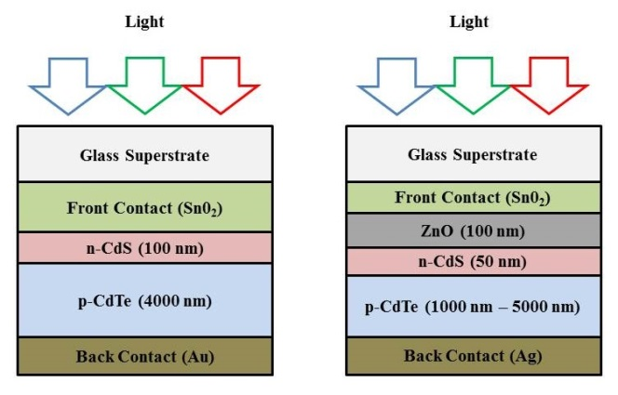
  - SCAP 1D Model

- CdTe Material Semiconductor Characteristics
  - FCC Lattice
  - Lab Scale Image

- CdTe EK Diagram
  - Band Diagram

- Working Principle
  - PN Junction https://youtu.be/L_q6LRgKpTw?t=224

  - Drift & Diffusion Current
  - IV- Characteristics (matlab)

- Improvements

- Conclusion

Anan’s Bibliography
- https://iopscience.iop.org/article/10.1088/1742-6596/1918/2/022029/pdf
- https://youtu.be/L_q6LRgKpTw
- https://corescholar.libraries.wright.edu/cgi/viewcontent.cgi?article=2915&context=etd_all
- https://youtu.be/GKqxMD_09Z4

Latex for Equations:

- w_{scr}=w_{p}+w_{n} = \frac{1}{N_{_{a}}}\cdot \sqrt{\frac{2\cdot\varepsilon _{s}}{q}\cdot\left ( \frac{1}{N_{_{a}}}+\frac{1}{N_{_{d}}}\right )\cdot V_b_i}

- D_n \cdot \frac{d^2n}{dx^2} + \mu_n F\cdot \frac{dn}{dx}+\mu_n n\cdot \frac{dF}{dx}-U_n+G_n=0
- D_p \cdot \frac{d^2p}{dx^2} + \mu_p F\cdot \frac{dp}{dx}+\mu_p p\cdot \frac{dF}{dx}-U_p+G_p=0
- V_b_i=\frac{1}{q} \left(\phi _n-\phi_p \right )
- V_b_i=\frac{k_bT}{q}\cdot ln \left(\frac{N_dN_a}{n_i^2} \right )

Presantation part:

Marifat:
Hello everyone my name is marifat haider. Today i and my groupmates are going to be presenting one of the most researched semiconductor devices and its physics behind working principles: Solar cell. Now conventional solar cells are mainly silicon based and efficient wise lags behind. Our topic is the Cdte thin film solar cells that are preferred over the conventional ones.

Solar cells are so embedded in our day to day life device uses that we basically know how a solar cell works. You have sunlight, you get electricity. We will get to that part sooner so, let me get you familiarised with Cdte thin film solar cell first.

CdTe based Photo voltaic is considered a thin film technology because the active layers are just a few microns thick. For CdTe having a band gap energy of 1.45 electron volts and high light absorption characteristics it costs less in fabrication thus more cost efficient than silicon ones.

Schematics of cdte solar cells look LIKE THIS. There are two configurations. This one is the substrat configuration. And this one is superstrate configuration.

The superstrate configuration:

On a glass layer Transparrent conducting oxide layer such as zinc oxide to transport current efficiently, in between is the Cds n type buffer layer for establishing an electric field at the heterojunction interface that collects the photogenerated charge carriers. The Cdte acts as the primary photoconversion layer and absorbs most visible light. Together CdTe, CdS and Transparrent conducting layer form an electrical field that converts light absorbed in the CdTe layer into current and voltage. Metal placed on the back to form electrical contacts. Making a good metal contact on CdTe is rather challenging. Material characteristic of CdTe do not let a large range of metal to work on with. Copper contain back contacts have been used for a long time but it has some draw backs itself like diffusion thru the cdte layers to the CdS layers. Now a days antimony tellirium is used instead.

Mentioned All these layers are deposited on the glass layer and proceeded into complete solar panels.

The substrate configuration is that either the substrate act like the back contact or the back contact is dipossited on the substrate. So the light enters from the Tranparrent conduction layer.

So, the basic difference is just the light illumination surface.

My group mate Raiyan Mahmuda will be taking it from here on.

Raiyan:

